UNIVERSITY OF MUMBAI
PROJECT REPORT ON
Payroll Management System
SUBMITTED BY
VIKRAM SURAJ PAL


DTSS COLLEGE OF COMMERCE UNDER THE GUIDANCE OF PROF. ABHIJIT PALSE

BSCIT SEM VI [2022-2023]


Ref No: Date:
CERTIFICATE

This is to certify that the project entitled PAYROLL MANAGEMENT SYSTEM Undertaken at the D.T.S.S. COLLEGE OF COMMERC & SCIENCE.

By

VIKRAM SURAJ PAL

In partial full filament of B.Sc.IT degree (Semester VI) Examination had not been submitted for any other examination and does not form part of any other course undergone by the candidate.
It is further certified that she has completed all required phases of project.

Signature of Internal Guide
Signature of External

Signature of the co-ordinate

Performa for the Approval Project Proposal

PNR NO: 2020016401575657 ROLL NO: 18

- Name of the Student
Vikram suraj pal

- Title of the Project
Payroll Management System

- Name of the Guide.
Prof. Abhijit palse

- Teaching experience of the Guide.
12 Years

- Is this your first Submission?

Yes ____ NO _____

Signature of the student Signature of Guide

Date Date

Signature of the co-ordinate
ABSTRACT

The actual problem is to maintain different database for an organization whose main purpose is to issue pay-slips for their employees every month working in various departments of the organization, and maintain details of all the departments, employees with various grades, their designations and address details.
In the manual system it is difficult to maintain data and generating different reports according to requesting transaction. In the present system it is becoming difficult to issue pay-slip for the entire employee every month by manually going through the various record of the organization. i.e. the manger have to go through all the records of the organization of various departments of the and find out the employee working in a particular department and go through his grade, and he have to check the employee leaves of that month, his earnings and his deductions along with his pf and all other deduction including his IT and savings. So, to perform all these activities it is becoming difficult the admin/manager every month.
Hence in order to overcome the difficulties of the organization the present system is automated to perform all the activities of the organization.

ACKNOWLEDGEMENT

In performing this project “PAYROLL MANAGEMENT SYSTEM”, I had to rake the help and guideline of some respected persons, who deserve our greatest gratitude.
The completion of this assignment gives me much pleasure. We would like to show our gratitude to Prof. Abhijit Palse for giving us a good guideline for project throughout numerous consultations.
We would also like to expand our deepest gratitude to all those who have directly and indirectly guided us in writing this project report.
Many people, especially our classmates and friends itself, have made valuable comments and suggestion on this proposal which gave an inspiration to improve my project.
Here I thank all the people for their help directly and indirectly to complete this project.

Table of Contents

Sr.No | Title | Page No
1 | Introduction | 1
 | 1.1 Abstract | 2
 | 1.2 Objectives | 3
 | 1.3 Purpose | 4
 | 1.4 Scope | 5
2 | Modules | 6
 | 2.1 Admin | 7
 | 2.2 Advantage | 7
 | 2.3 Disadvantage | 7
3 | Survey of Technology | 8
4 | Feasibility Study | 9
5 | Project Category | 10
 | 5.1 Web Based Application | 10
6 | System Design | 11
 | 6.1 ER Diagram | 11
 | 6.2 Activity Diagram | 12
 | 6.3 Class Diagram | 13
 | 6.4 Use Case Diagram | 14
 | 6.5 Sequence Diagram | 15
 | 6.6 Data Flow Diagram | 16
 | 6.7 Component Diagram | 17
 | 6.8 Deployment Diagram | 18
 | 6.9 Gantt Chart | 19
 | 6.10 Database Table | 20
7 | Screenshots | 25
8 | Source Code | 30
9 | Features of the Project | 58
10 | Future Scope Of this Work | 59
11 | Conclusion | 60
12 | Bibliography | 61

PAYROLL MANAGEMENT SYSTEM
INTRODUCTION
The “Payroll Management System” has been developed to override the problems prevailing in the practicing manual system. This software is supported to eliminate and in some cases reduce the hardship faced by this existing system. Moreover this system is designed for the particular need of the company to carry out operations in a smooth and effective manner.
Every organization, whether big or small, has challenges to overcome and managing the information’s of Employee, Payroll, Appraisals, Payments, and Working Points. Every Payroll Management System has different Payroll needs; therefore we design exclusive employee management systems that are adapted to your managerial requirements. This is designed to assist in strategic planning, and will help you ensure that your organisation is equipped with the right level of information and details for your future goals. Also, for those busy executive who are always on the go, our systems come with remote access features, which will allow you to manage your workforce anytime, at all times. These systems will ultimately allow you to better manage resources.
The application is reduced as much as possible to avoid errors while entering the data. It also provides error message while entering invalid data. No formal knowledge is needed for the user to use this system. Thus by this all it proves it is user-friendly. Payroll Management System, as described above, can lead to error free, secure, reliable and fast management system. It can assist the user to concentrate on their other activities rather to concentrate on the record keeping. Thus it will help organization in better utilization pf resources.
The proposed project “Payroll Management System” has been developed to overcome the problems faced in the practicing of manual system. This software is built to eliminate and in some cases reduce the hardships faced by the existing system. Moreover this system is designed for particular need of the company to carry out its operations in a smooth and effective manner. This web application is reduced as much as possible to avoid errors while entering data. It also provides error message while entering invalid data. It is user-friendly as no formal knowledge is required to use the system. Human resource challenges are faced by every organization which has to be overcome by the organization. Every organization has different employee and payroll management needs. Therefore I have design exclusive payroll Management System that are adapted to the organization’s Managerial Requirement
1.1 ABSTRACT

The purpose of Payroll Management System is to automate the existing manual system by the help of computerized equipment and full-fledged computer software, fulfilling their requirements, so that their valuable data/information can be stored for a longer period with easy accessing and manipulation of the same. The required software and hardware are easily available and easy to work with.
Payroll Management System, as described above, can lead to error free, secure, reliable and fast management system. It can assist the user to concentrate in their other activities rather to concentrate on the record keeping. Thus it will help organization in better utilization of resources. The organization can maintain computerized records without redundant entries. That means that one need not be distracted by information that is not relevant, while being able to reach the information.
The aim is to automate its existing manual system by the help of computerized equipment’s and full-fledged computer software, fulfilled their requirement, so that their valuable data/information can be stored for a longer period with easy accessing and manipulation of the same. Basically the project describes how to manage for good performance and better services for the clients.
The required software is easily available and easy to work with. This web application can maintain and view computerised records without getting redundant entries. The project describes how to manage user data for good performance and provide better services for the client.

1.2 OBJECTIVE

The main objective of the project on Payroll Management System is to manage the details of payroll. Employee, Salary, Appraisals, Working Points. It manages all the information about Payroll, Payments, Working Points, and Payroll. The project is totally built at administrative end and thus only the administrator is guaranteed the access. The purpose of the project is to project is to build an application program to reduce the manual work for managing the Payroll. Employee, Payments, Salary, It tracks all the details about the Salary, Appraisals, Working Points.
To assist ease the works of the Retails Outlet of Any Type of Companies, in particular, Payroll Management System is being developed. This would comprise the features that can be operated easily. Payroll Management System would take care of the Day to day Attendance of All Employee. It covers activities from keeping the details of day to dayIn, Out, OD etc. The master and transaction activities are divided in modules so that the activities can be operated easily. The regular backup to the data can be taken and the backup data can be restored effectively. So, the Payroll Management System assists the employees of Company in each and every aspect of In and Out. The Payroll Management System is customized software and developed according to the needs of Any Type Company.

1.3 PURPOSE

The purpose of this document is to describe the functionality and specifications of the design of a web application for Managing Employees and their payroll. The expected audiences of this document are the developers and the admin of the web application. Now with the help of this system the admin has the information on his finger tips and can easily prepare a good record based on their requirements. Finally, we can say that this system will not only automate the process but save the valuable time of the manager or the admin, which can be well utilized buy his institute. This will be an additional advantage and management of power based on their free time from his normal duty.
The purpose of the project is to maintain the information regarding the employees and generates the pay slip. Main aim of developing Payroll Management System is to provide an easy way not only to automate all functionalities involved managing leaves and Payroll for the employee of Company, But also to provide full functional reports to management of Company with the details about usage of leave facility and Salaries Paid or to be paid to employees.
We are committed to bring the best way to management in the various forms of EPM. We understand that EPM in not just a product to be sold, it is a tool to manage the inner operation of Company related to employee leave and Payroll.

1.4 Scope

It may help collecting perfect management in details. In a very short time, the collection will be obvious, Simple and sensible. It will be help a person to know the management of passed year perfectly and vividly. It also helps n current all works relative to Payroll Management System. It will be also reduce the cost of collecting the management & collection procedure will go on smoothly.
Our project aims at Business process automation, i.e. we have tried to computerize various processes of Payroll Management System.
- In computer system the person has to fill the various forms & number of copies of the forms can be easily generated at a time.
- In computer system, it is not necessary to create the manifest but we can directly print it, which saves our time.
- To assist the staff in capturing the effort spent on their respective working areas.
- To utilize resources in an efficient manner by increasing their productivity through automation.
- The system generates types of information that can be used for various purposes.
- It satisfy the user requirement
- Be easy to understand by the user and operator
- Be easy to operate
- Have a good user interface
- BE expandable
- Delivered on schedule within the budget

2. MODULES

  - Payroll Management Module: Used for managing the payroll details.
  - Working Points Modules: Used for managing the details of working Points.
  - Payments Modules: Used for managing the details of Payments.
  - Employee Management Modules: Used for managing the information and details of the Employee.
  - Salary Module: Used for managing the Salary details.
  - Appraisals Modules: Used for managing the Appraisals information.
  - Login Module: Used for managing the login details.
  - Users Module: Used for managing the users of the system.

ADMIN
The Admin gets logged in by valid username and password. Admin can add new Employee, add new Department, adds new Pay Grade for the employees. Admin can set the ‘from’ and ‘to’ date worked by an employee in a department with specific pay grade. The Admin can generate an automated monthly salary of an employee. The admin can view all the past records of any recorded employee.

ADVANTAGE
- It is cost effective as the user control the web application himself and does not go for professional service.
- It saves time as it speeds up every aspect of the employee database management and payroll process with a range of automated features.
- It is secure as the employee database and the payroll process is managed by the admin in house rather than sending private information to a third party.
- Validating procedures and checks restrict user from making mistakes.
- The software is easy to use and is user friendly so no expertise is required.
- The calculations are automated so no chance of error.

DISADVANTAGE
- It requires an internet connection.
- It requires large database.

3. Survey of Technology (change karna hhai)

Front end: JAVA, AWT, SWING
- JAVA: Java is known as one of the powerful general-purpose programming languages. This program is designed to impart complete knowledge of Java full-stack application or website development, improve your soft skills and aptitude skills and enable you to be business ready.
- AWT AND SWING: AWT and Swing are used to develop window-based applications in Java. Awt is an abstract window toolkit that provides various component classes like Label, Button, Text Field, etc., to show window components on the screen. All these classes are part of the Java.awt package.

Back end: PHP, MySQL
- PHP: Hypertext Pre-processors (PHP) is a technology that allows software developers to create dynamically generated web pages, in HTML, XML, or other document types, as per client request. PHP is open source software.
- MySQL: MySQL is a database, widely used for accessing querying, updating and managing data in databases.
4. FEASIBILITY STUDY

After identifying the scope of the project, the feasibility study is needed to be carried out. It is basically keeping the following points in mind.

Building the software for meeting the scope: This software has met the scope. As there is no data involved in the system, processing on the file, and the behavior of this project is already identified and bundled in quantitative manner.
The processing of this software is very simple as it has been designed in php and it has been well divided into several functions according to the need.

Technically feasible: This software is very much technically feasible. This software is very much concerned with specifying equipment and the software will successfully satisfy almost all the adman’s requirements. The technical need for this system may vary considerably but might include:
- The facility to produce output in a given time.
- Response time under certain conditions.
- Ability to process data at a particular speed

State of Art: The project is very much within the state of art since the project is a WINDOWS based; it uses very modern and common technique.
Beside it is very much modern and user friendly. It also works as middleware i.e. only in between the user and the file. So, it is completely a state of art project.

Financially Feasible: The project is very much financially feasible. The implementation and development cost of this software under the reach of any college.
Moreover, it requires some training for the use. So, training cost can be neglected and the resources of this software are very much available. It also reduces the labour and extra cost to be paid for labor. So indeed, it is financially feasible.

Resources: As motioned earlier that the resources are easily available and the cost of training is almost negligible. Sometimes situations may arise when it may not be so much easy. For a person completely unaware of using a computer system could result in a training cost or for a very small organization the purchase of a computer, instalment of the system and other charges may lead to a difficult matter.

5. PROJECT CATEGORY

  - WEB BASED APPLICATION

Available Technologies:
Languages: Java, Awt, Swing
Database: MYSQL

Tools Used:
Editor Used: Net beans IDE 17, MySQL
Operating System: Windows 10

Hardware Used:
Processor: Intel core i3
RAM: 2GB
Hard Disk: 1TB

6. SYSTEM DESIGN

- 6.1 Entity Relationship Diagram (ERD):

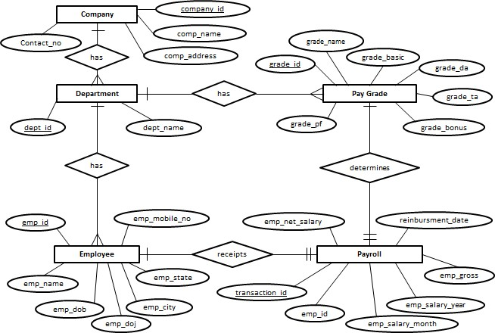

- 6.2 ACTIVITY DIAGRAM:



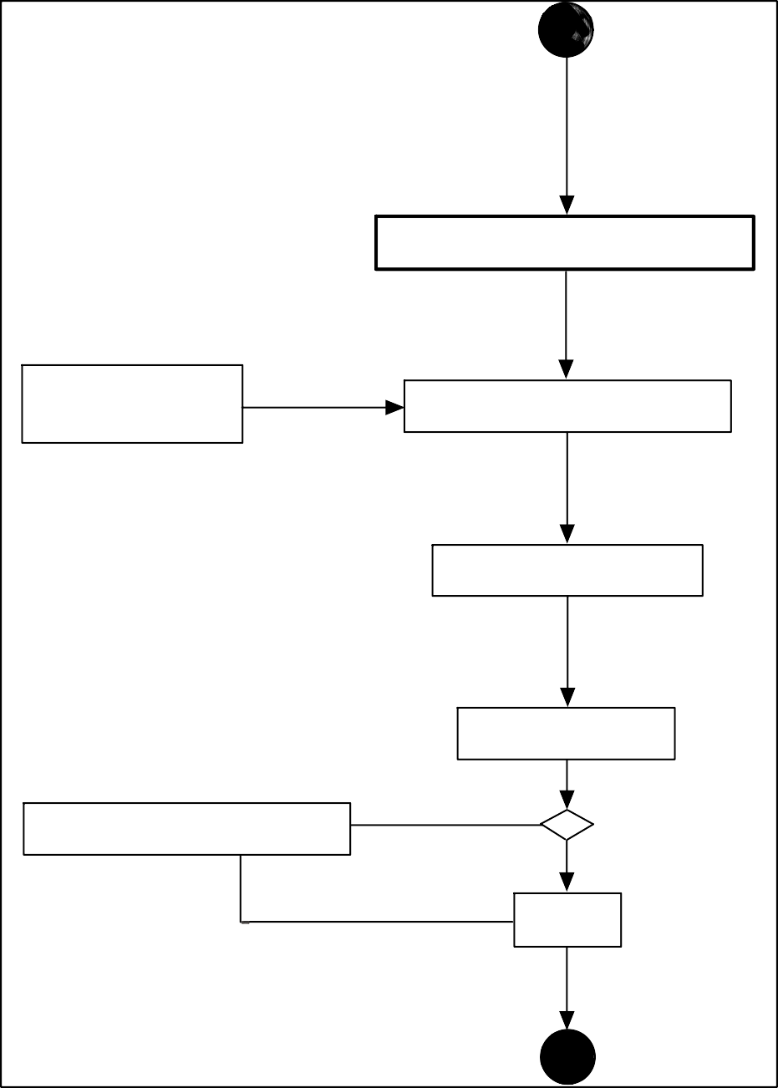

- 6.3 CLASS DIAGRAM:

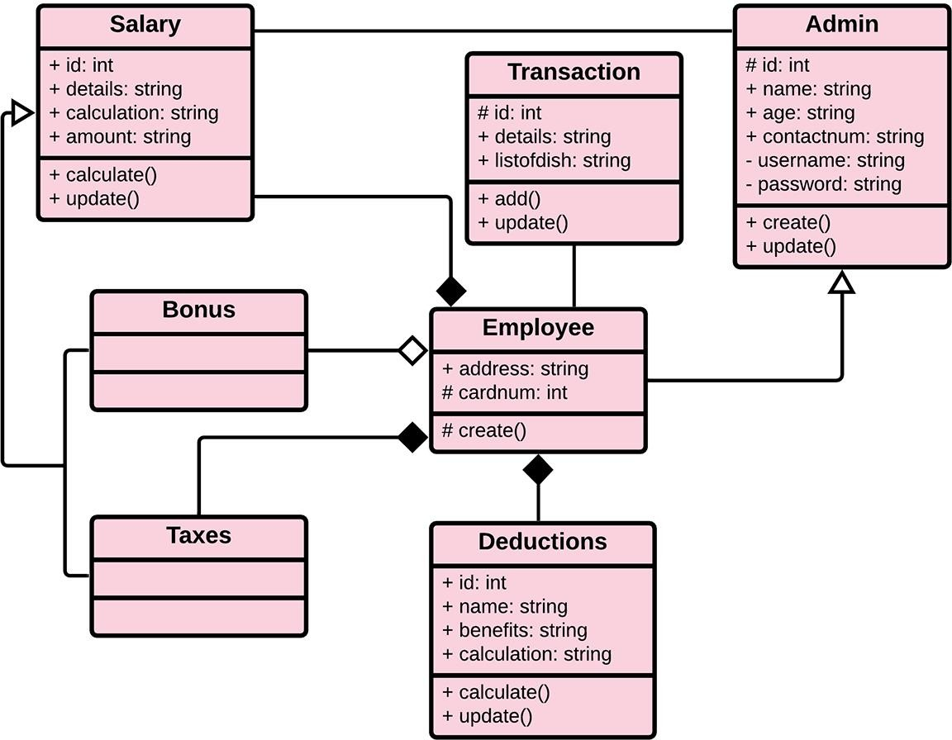

- 6.4 USE CASE DIAGRAM:

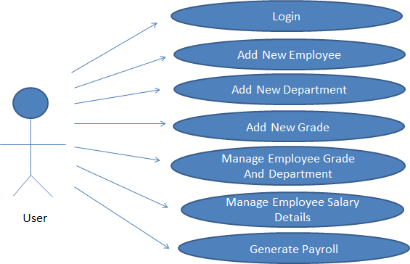

- 6.5 SEQUENCE DIAGRAM:

Open application
Enter Login credentials
Successfully logged in
Select required option
Request for required option
Required option selected successfully
Display required page
Insert the required details
Passes entered details
Details entered successfully
Display the details entered
Select record
Request for Report
Display the Report
Report
USER APPLICATION DATABASE

- 6.6 DATA FLOW DIAGRAM:
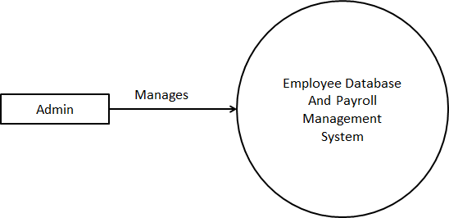
Level 0

Level 1
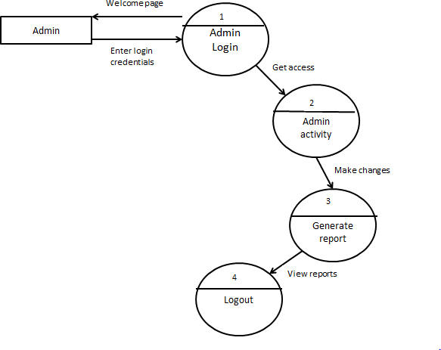

- 6.7 COMPONENT DIAGRAM:

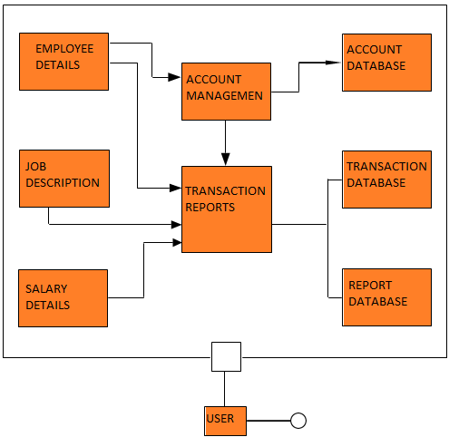

- 6.8 DEPLOYMENT DIAGRAM:

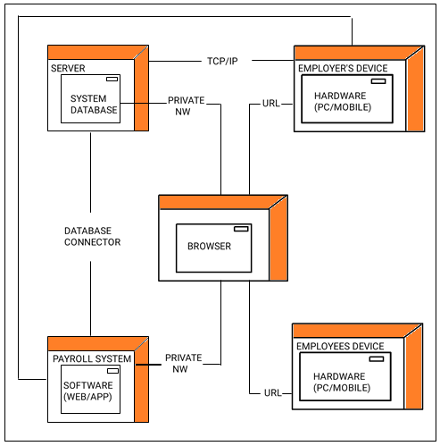

6.9 Gantt chart

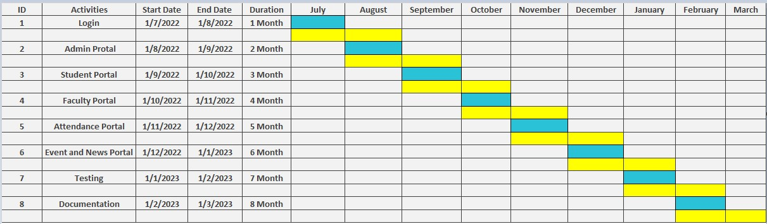
.

Start Date
End Date

6.10 DATABASE TABLE
- USER TABLE DATABASE STRUCTURE:

User_id(int) – primary Key | Id for the user
UserNames(varchar) | Enter the name of the user.
Password(varchar) | Enter the password of the user.
email(varchar) | Enter the email_id of the user.
user type(varchar) | Enter the type of user.

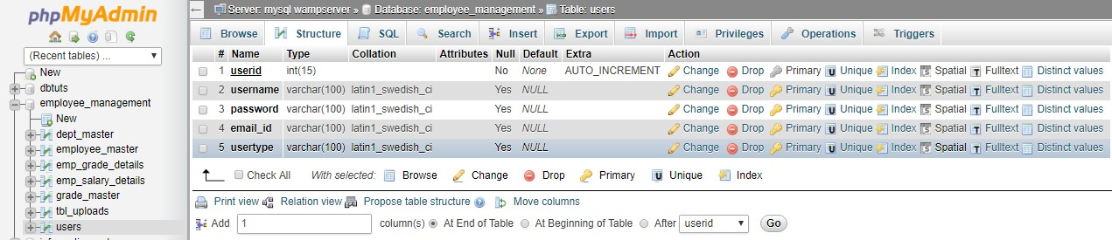

- DEPARTMENT TABLE DATABASE STRUCTURE:
Dept_id(INT) – Primary Key | Id of the Department
Dept_name(varchar) | Name of the Department

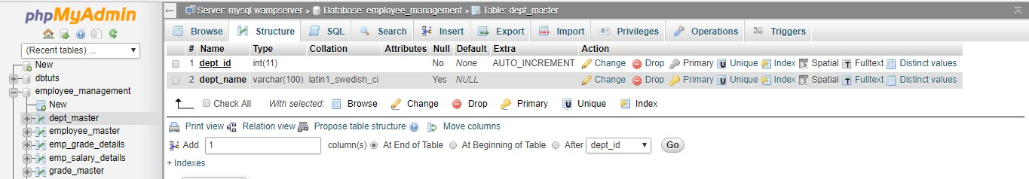

- GRADE TABLE DATABASE STRUCTURE:

Grade_id(int) - Primary Key | Id of the pay grade.
Grade_name(varchar) | Name of the pay grade.
Grade_short_name(varchar) | Short name of the pay grade
Grade_basic(int) | Enter the basic amount.
Grade_ta(int) | The amount of the Travel Allowance.
Grade_da(int) | The amount of the Dearness Allowance.
Grade_hra(int) | The amount of the House Rent Allowance.
Grade_ma(int) | The amount of Medical Allowance.
Grade_bonus(int) | The amount of bonus received.
Grade_pt(int) | Amount of Provident Fund to be deducted
Grade_pt(int) | Amount of Professional Tax to be deducted

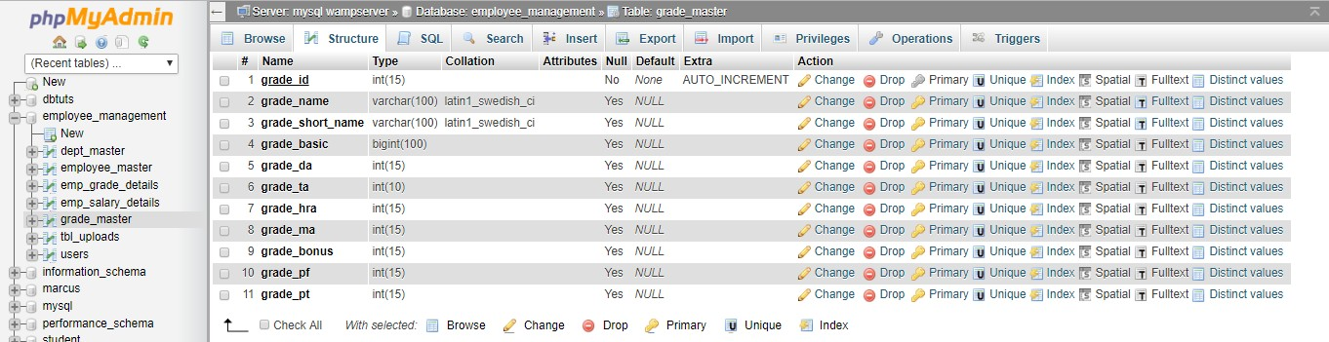

- EMPLOYEE TABLE DATABASE STRUCTURE:

emp_id(int) – Primary Key | Id of the employee.
emp_title(varchar) | Enter the title of employee.
emp_name(varchar) | Enter the name of employee.
emp_dob(date) | Enter the date of birth of employee.
emp_doj(date) | Enter the date of join of employee.
emp_address(varchar) | Enter the address of the employee.
emp_city(varchar) | Enter the city of the employee.
emp_pincode(int) | Enter the pin code of the employee.
emp_mobile_no(int) | Enter the mobile number of the employee.
emp_state(varchar) | Enter the state of the employee.
emp_mail_id(varchar) | Enter the mail id of the employee.
emp_pan_no(varchar) | Enter the Pan number of the employee.
Emp_upload_pan() | Enter the pan card image of the employee.
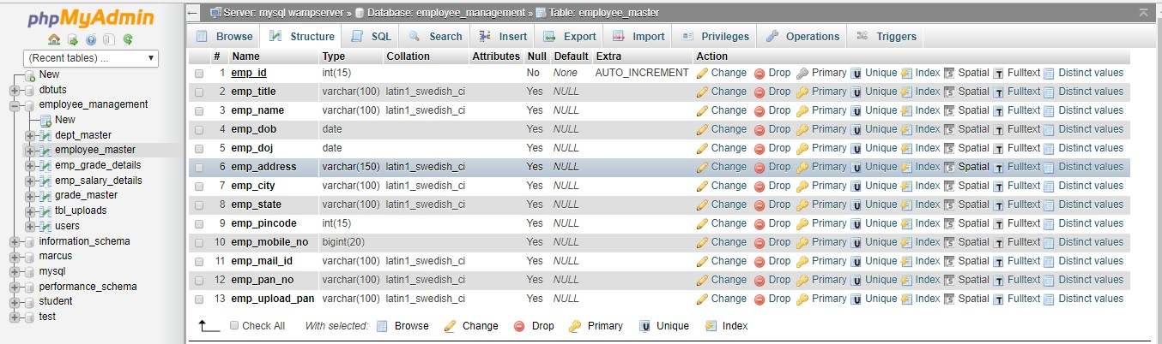

- Employee Grade Details Table Database Structure:

transaction_id(int)- Primary Key | Unique transaction id.
emp_id(int) | Employee id of employee.
emp_dept_id(int) | Department Id of employee
emp_grade_id(int) | Grade Id of employee.
emp_from_date(date) | Date of join of employee in a department.
emp_to_date(varchar) | Last date of an employee in a department.
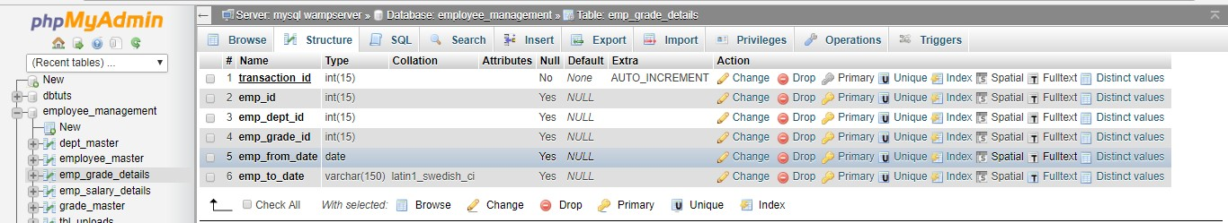

- Employee Salary Details Table Database Structure:

transaction_id(int) -Primary Key | Unique primary key.
emp_id(int) | Employee Id of employee
emp_salary_month(varchar) | Employee Salary month.
emp_salary_month(varchar) | Employee salary year.
emp_salary_eimbursment_date(date time) | The date and time when employee salary was generated.
emp_dept_id(int) | Department Id of the employee.
emp_grade_id(int) | grade id of the employee
emp_basic(int) | Enter the amount of the basic.
emp_da(int) | The amount of dearness Allowance.

emp_ta(int) | The amount of travel allowance.
emp_hra(int) | The amount of House Rent Allowance.
emp_ma(int) | The amount of Medical Allowance.
emp_bonus(int) | The amount of Bonus
emp_pf(int) | The amount of Provident Fund to be deducted.
emp_pt(int) | The amount of Professional Tax to be deducted.
emp_gross(int) | The gross total received by employee.
emp_total_salary(int) | The total salary received after deduction.


- Screenshots

- Welcome :
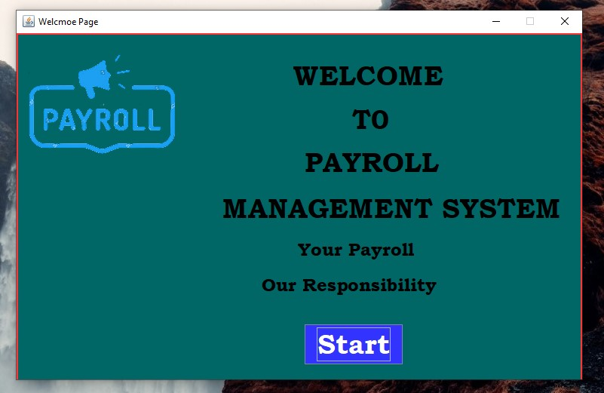

- Login Page :
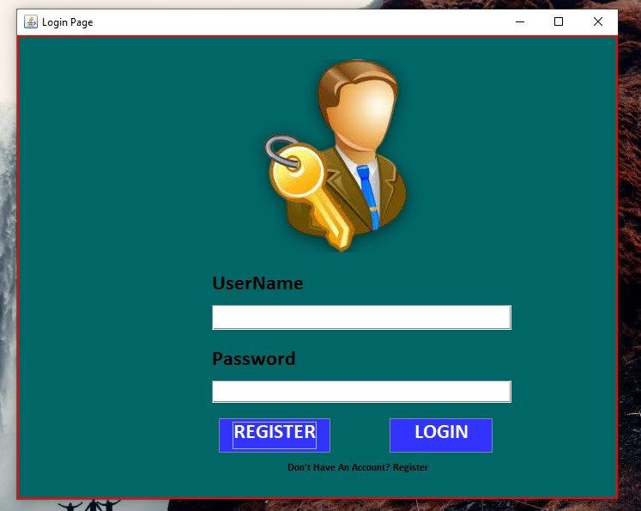

- Register Page :

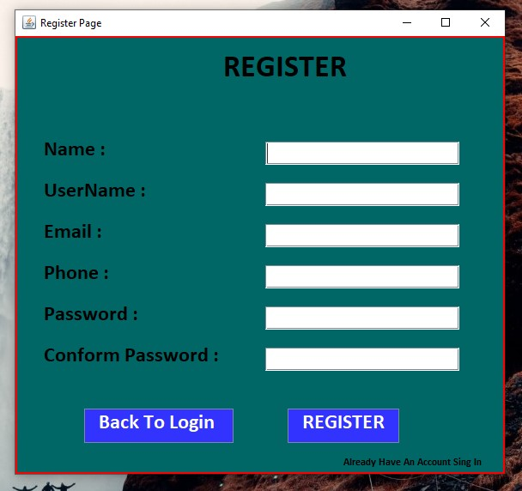

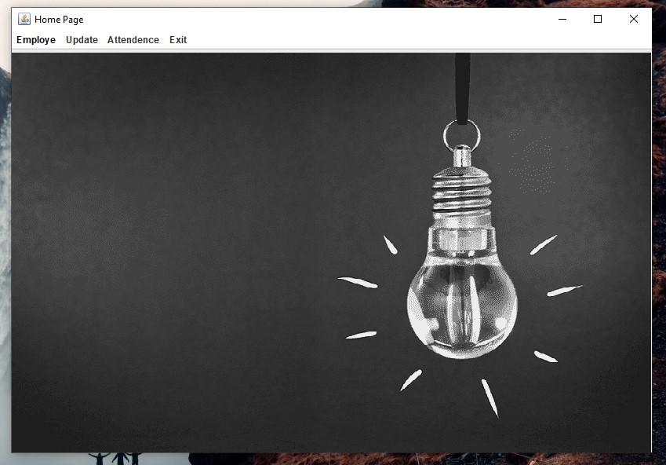
- Home Page :
- New Employe Page :

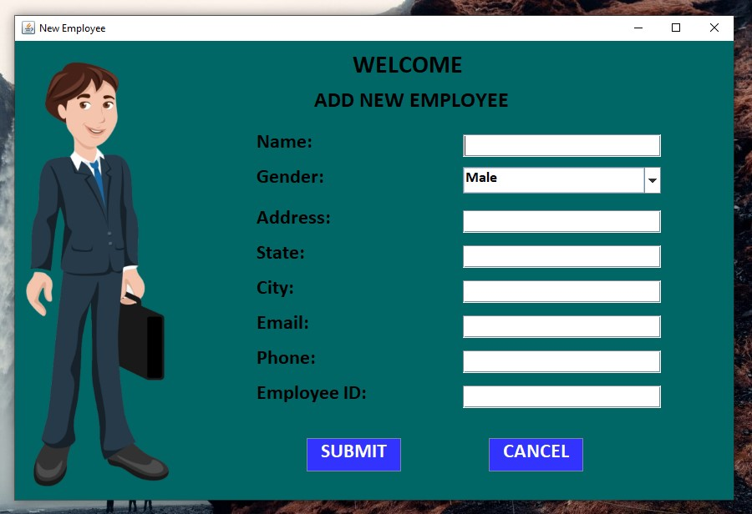

- Salary Page :

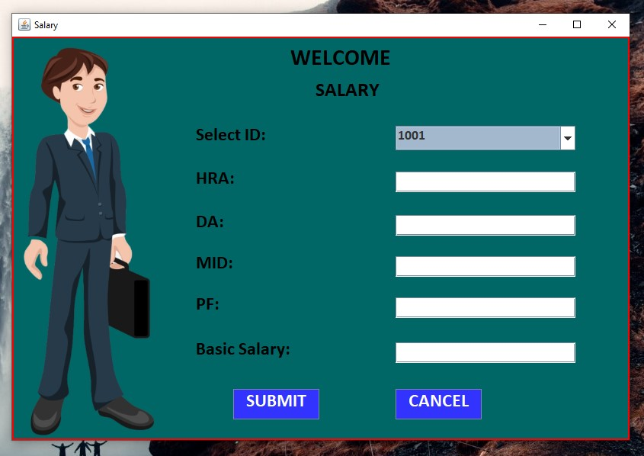

- Take Attendence Page :

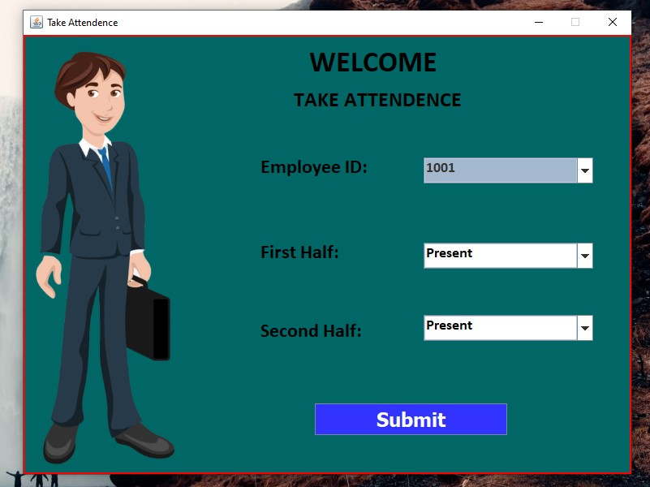

- Update Employe Page :

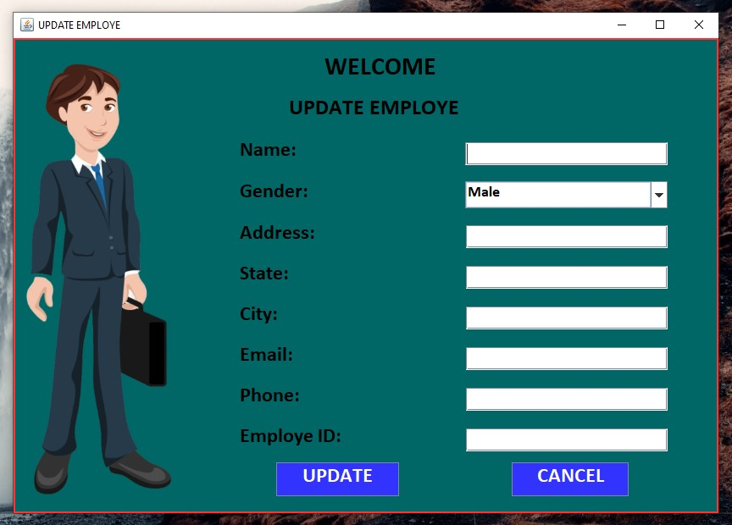

- Update Salary Page :

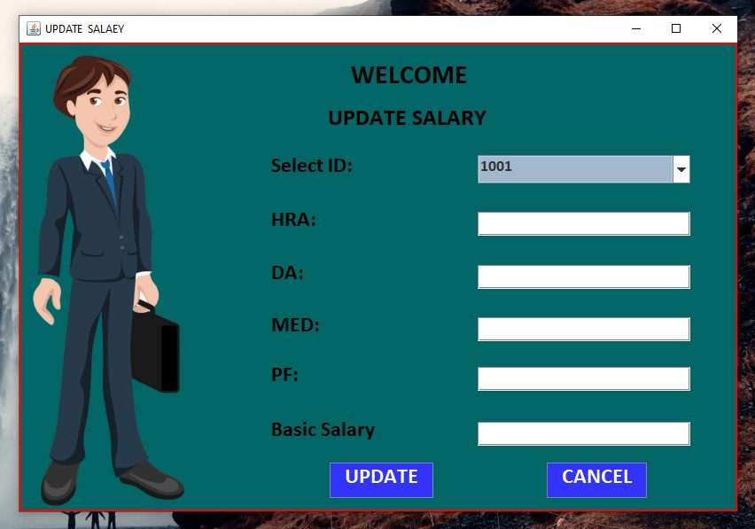

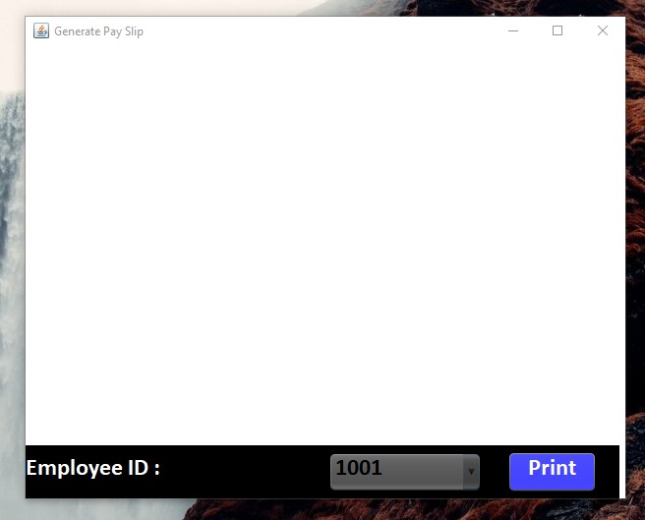
- Generate Pay Slip Page:

8. Source Code

Welcome:

package Payroll_Project;

import java.awt.Font;

public class Welcome_page extends javax.swing.JFrame {

public Welcome_page() {
super ("Welcome page");
setSize(300, 0xb4);
setLocation(500,200);
setResizable(false);
String calibri = null;

Font t = new Font(calibri,Font.BOLD,14);
initComponents();
}

@SuppressWarnings("unchecked")
// <editor-fold defaultstate="collapsed" desc="Generated Code">
private void initComponents() {

jPanel1 = new javax.swing.JPanel();
jLabel3 = new javax.swing.JLabel();
jLabel2 = new javax.swing.JLabel();
Login = new javax.swing.JButton();
jLabel1 = new javax.swing.JLabel();
jLabel4 = new javax.swing.JLabel();
jLabel5 = new javax.swing.JLabel();
jLabel6 = new javax.swing.JLabel();
jLabel7 = new javax.swing.JLabel();

setDefaultCloseOperation(javax.swing.WindowConstants.DISPOSE_ON_CLOSE);
setTitle("Welcmoe Page");
getContentPane().setLayout(new org.netbeans.lib.awtextra.AbsoluteLayout());

jPanel1.setBackground(new java.awt.Color(0, 102, 102));
jPanel1.setBorder(javax.swing.BorderFactory.createMatteBorder(2, 2, 2, 2, new java.awt.Color(255, 51, 51)));

jLabel3.setBackground(new java.awt.Color(0, 102, 102));
jLabel3.setFont(new java.awt.Font("Bookman Old Style", 1, 24)); // NOI18N
jLabel3.setForeground(new java.awt.Color(0, 0, 0));
jLabel3.setText("Our Responsibility");

jLabel2.setBackground(new java.awt.Color(0, 153, 153));
jLabel2.setFont(new java.awt.Font("Bookman Old Style", 1, 24)); // NOI18N
jLabel2.setForeground(new java.awt.Color(0, 0, 0));
jLabel2.setText("Your Payroll");

Login.setBackground(new java.awt.Color(51, 51, 255));
Login.setFont(new java.awt.Font("Bookman Old Style", 1, 36)); // NOI18N
Login.setForeground(new java.awt.Color(255, 255, 255));
Login.setText("Start");
Login.addActionListener(new java.awt.event.ActionListener() {
public void actionPerformed(java.awt.event.ActionEvent evt) {
LoginActionPerformed(evt);
}
});

jLabel1.setBackground(new java.awt.Color(0, 102, 102));
jLabel1.setFont(new java.awt.Font("Bookman Old Style", 1, 36)); // NOI18N
jLabel1.setForeground(new java.awt.Color(0, 0, 0));
jLabel1.setText("WELCOME");

jLabel4.setBackground(new java.awt.Color(0, 102, 102));
jLabel4.setFont(new java.awt.Font("Bookman Old Style", 1, 36)); // NOI18N
jLabel4.setForeground(new java.awt.Color(0, 0, 0));
jLabel4.setText(" PAYROLL ");

jLabel5.setBackground(new java.awt.Color(0, 102, 102));
jLabel5.setFont(new java.awt.Font("Bookman Old Style", 1, 36)); // NOI18N
jLabel5.setForeground(new java.awt.Color(0, 0, 0));
jLabel5.setText(" T0");

jLabel6.setBackground(new java.awt.Color(0, 102, 102));
jLabel6.setFont(new java.awt.Font("Bookman Old Style", 1, 36)); // NOI18N
jLabel6.setForeground(new java.awt.Color(0, 0, 0));
jLabel6.setText("MANAGEMENT SYSTEM");

jLabel7.setIcon(new javax.swing.ImageIcon("D:\\Payroll_project\\icone\\payroll-1.png")); // NOI18N
jLabel7.setText("jLabel7");

javax.swing.GroupLayout jPanel1Layout = new javax.swing.GroupLayout(jPanel1);
jPanel1.setLayout(jPanel1Layout);
jPanel1Layout.setHorizontalGroup(
jPanel1Layout.createParallelGroup(javax.swing.GroupLayout.Alignment.LEADING)
.addGroup(jPanel1Layout.createSequentialGroup()
.addContainerGap()
.addGroup(jPanel1Layout.createParallelGroup(javax.swing.GroupLayout.Alignment.LEADING)
.addGroup(jPanel1Layout.createSequentialGroup()
.addComponent(jLabel7, javax.swing.GroupLayout.PREFERRED_SIZE, 200, javax.swing.GroupLayout.PREFERRED_SIZE)
.addGroup(jPanel1Layout.createParallelGroup(javax.swing.GroupLayout.Alignment.LEADING)
.addGroup(jPanel1Layout.createSequentialGroup()
.addGap(153, 153, 153)
.addComponent(jLabel1))
.addGroup(jPanel1Layout.createSequentialGroup()
.addGap(207, 207, 207)
.addComponent(jLabel5))
.addGroup(jPanel1Layout.createSequentialGroup()
.addGap(132, 132, 132)
.addComponent(jLabel4, javax.swing.GroupLayout.PREFERRED_SIZE, 244, javax.swing.GroupLayout.PREFERRED_SIZE)))
.addContainerGap(164, Short.MAX_VALUE))
.addGroup(javax.swing.GroupLayout.Alignment.TRAILING, jPanel1Layout.createSequentialGroup()
.addGap(0, 0, Short.MAX_VALUE)
.addGroup(jPanel1Layout.createParallelGroup(javax.swing.GroupLayout.Alignment.LEADING)
.addGroup(javax.swing.GroupLayout.Alignment.TRAILING, jPanel1Layout.createSequentialGroup()
.addComponent(jLabel3)
.addGap(191, 191, 191))
.addGroup(javax.swing.GroupLayout.Alignment.TRAILING, jPanel1Layout.createSequentialGroup()
.addComponent(Login)
.addGap(236, 236, 236))))))
.addGroup(javax.swing.GroupLayout.Alignment.TRAILING, jPanel1Layout.createSequentialGroup()
.addGap(0, 0, Short.MAX_VALUE)
.addGroup(jPanel1Layout.createParallelGroup(javax.swing.GroupLayout.Alignment.LEADING)
.addGroup(javax.swing.GroupLayout.Alignment.TRAILING, jPanel1Layout.createSequentialGroup()
.addComponent(jLabel2)
.addGap(221, 221, 221))
.addGroup(javax.swing.GroupLayout.Alignment.TRAILING, jPanel1Layout.createSequentialGroup()
.addComponent(jLabel6)
.addGap(26, 26, 26))))
);
jPanel1Layout.setVerticalGroup(
jPanel1Layout.createParallelGroup(javax.swing.GroupLayout.Alignment.LEADING)
.addGroup(jPanel1Layout.createSequentialGroup()
.addContainerGap()
.addGroup(jPanel1Layout.createParallelGroup(javax.swing.GroupLayout.Alignment.TRAILING)
.addComponent(jLabel7, javax.swing.GroupLayout.Alignment.LEADING, javax.swing.GroupLayout.PREFERRED_SIZE, 158, javax.swing.GroupLayout.PREFERRED_SIZE)
.addGroup(javax.swing.GroupLayout.Alignment.LEADING, jPanel1Layout.createSequentialGroup()
.addGap(21, 21, 21)
.addComponent(jLabel1)
.addGap(18, 18, 18)
.addComponent(jLabel5, javax.swing.GroupLayout.PREFERRED_SIZE, 36, javax.swing.GroupLayout.PREFERRED_SIZE)
.addGap(18, 18, 18)
.addComponent(jLabel4)))
.addGap(18, 18, 18)
.addComponent(jLabel6)
.addGap(18, 18, 18)
.addComponent(jLabel2)
.addGap(18, 18, 18)
.addComponent(jLabel3)
.addGap(38, 38, 38)
.addComponent(Login)
.addContainerGap(129, Short.MAX_VALUE))
);

getContentPane().add(jPanel1, new org.netbeans.lib.awtextra.AbsoluteConstraints(0, 0, 750, 560));

setBounds(0, 0, 766, 498);
}// </editor-fold>

private void LoginActionPerformed(java.awt.event.ActionEvent evt) {
new Login_Form().setVisible(true);

}

public static void main(String args[]) {

java.awt.EventQueue.invokeLater(new Runnable() {
public void run() {
new Welcome_page().setVisible(true);
}
});
}

// Variables declaration - do not modify
private javax.swing.JButton Login;
private javax.swing.JLabel jLabel1;
private javax.swing.JLabel jLabel2;
private javax.swing.JLabel jLabel3;
private javax.swing.JLabel jLabel4;
private javax.swing.JLabel jLabel5;
private javax.swing.JLabel jLabel6;
private javax.swing.JLabel jLabel7;
public javax.swing.JPanel jPanel1;
// End of variables declaration

private static class Login {

public Login() {
}
}
}

:

package Payroll_Project;

public class Login_Form extends javax.swing.JFrame {

public Login_Form() {
initComponents();
}

@SuppressWarnings("unchecked")
// <editor-fold defaultstate="collapsed" desc="Generated Code">
private void initComponents() {

jPanel1 = new javax.swing.JPanel();
jLabel1 = new javax.swing.JLabel();
UserName = new javax.swing.JLabel();
Password = new javax.swing.JLabel();
tfusername = new javax.swing.JTextField();
btnLogin = new javax.swing.JButton();
tfPassword = new javax.swing.JPasswordField();
btnRegester = new javax.swing.JButton();
jLabel2 = new javax.swing.JLabel();

setDefaultCloseOperation(javax.swing.WindowConstants.DISPOSE_ON_CLOSE);
setTitle("Login Page");
getContentPane().setLayout(new org.netbeans.lib.awtextra.AbsoluteLayout());

jPanel1.setBackground(new java.awt.Color(0, 102, 102));
jPanel1.setBorder(javax.swing.BorderFactory.createMatteBorder(2, 2, 2, 2, new java.awt.Color(255, 0, 0)));

jLabel1.setIcon(new javax.swing.ImageIcon("D:\\login-1.png")); // NOI18N

UserName.setBackground(new java.awt.Color(0, 102, 102));
UserName.setFont(new java.awt.Font("Calibri", 1, 24)); // NOI18N
UserName.setForeground(new java.awt.Color(0, 0, 0));
UserName.setText("UserName");

Password.setBackground(new java.awt.Color(0, 102, 102));
Password.setFont(new java.awt.Font("Calibri", 1, 24)); // NOI18N
Password.setForeground(new java.awt.Color(0, 0, 0));
Password.setText("Password");

tfusername.setBackground(new java.awt.Color(255, 255, 255));
tfusername.setFont(new java.awt.Font("Calibri", 1, 18)); // NOI18N
tfusername.setForeground(new java.awt.Color(0, 0, 0));
tfusername.addActionListener(new java.awt.event.ActionListener() {
public void actionPerformed(java.awt.event.ActionEvent evt) {
tfusernameActionPerformed(evt);
}
});

btnLogin.setBackground(new java.awt.Color(51, 51, 255));
btnLogin.setFont(new java.awt.Font("Calibri", 1, 24)); // NOI18N
btnLogin.setForeground(new java.awt.Color(255, 255, 255));
btnLogin.setText("LOGIN");
btnLogin.addActionListener(new java.awt.event.ActionListener() {
public void actionPerformed(java.awt.event.ActionEvent evt) {
btnLoginActionPerformed(evt);
}
});

tfPassword.setBackground(new java.awt.Color(255, 255, 255));
tfPassword.setFont(new java.awt.Font("Cambria", 1, 18)); // NOI18N
tfPassword.setForeground(new java.awt.Color(0, 0, 0));

btnRegester.setBackground(new java.awt.Color(51, 51, 255));
btnRegester.setFont(new java.awt.Font("Calibri", 1, 24)); // NOI18N
btnRegester.setForeground(new java.awt.Color(255, 255, 255));
btnRegester.setText("REGISTER");
btnRegester.addActionListener(new java.awt.event.ActionListener() {
public void actionPerformed(java.awt.event.ActionEvent evt) {
btnRegesterActionPerformed(evt);
}
});

jLabel2.setBackground(new java.awt.Color(0, 102, 102));
jLabel2.setFont(new java.awt.Font("Calibri", 1, 12)); // NOI18N
jLabel2.setForeground(new java.awt.Color(0, 0, 0));
jLabel2.setText(" Don't Have An Account? Register");

javax.swing.GroupLayout jPanel1Layout = new javax.swing.GroupLayout(jPanel1);
jPanel1.setLayout(jPanel1Layout);
jPanel1Layout.setHorizontalGroup(
jPanel1Layout.createParallelGroup(javax.swing.GroupLayout.Alignment.LEADING)
.addGroup(jPanel1Layout.createSequentialGroup()
.addGroup(jPanel1Layout.createParallelGroup(javax.swing.GroupLayout.Alignment.LEADING)
.addGroup(jPanel1Layout.createSequentialGroup()
.addGap(256, 256, 256)
.addComponent(jLabel1, javax.swing.GroupLayout.PREFERRED_SIZE, 247, javax.swing.GroupLayout.PREFERRED_SIZE))
.addGroup(jPanel1Layout.createSequentialGroup()
.addGap(225, 225, 225)
.addGroup(jPanel1Layout.createParallelGroup(javax.swing.GroupLayout.Alignment.LEADING)
.addComponent(UserName)
.addComponent(tfusername, javax.swing.GroupLayout.PREFERRED_SIZE, 349, javax.swing.GroupLayout.PREFERRED_SIZE)
.addComponent(Password)
.addComponent(tfPassword, javax.swing.GroupLayout.PREFERRED_SIZE, 349, javax.swing.GroupLayout.PREFERRED_SIZE)))
.addGroup(jPanel1Layout.createSequentialGroup()
.addGap(233, 233, 233)
.addComponent(btnRegester)
.addGap(69, 69, 69)
.addComponent(btnLogin, javax.swing.GroupLayout.PREFERRED_SIZE, 120, javax.swing.GroupLayout.PREFERRED_SIZE))
.addGroup(jPanel1Layout.createSequentialGroup()
.addGap(304, 304, 304)
.addComponent(jLabel2, javax.swing.GroupLayout.PREFERRED_SIZE, 180, javax.swing.GroupLayout.PREFERRED_SIZE)))
.addContainerGap(206, Short.MAX_VALUE))
);
jPanel1Layout.setVerticalGroup(
jPanel1Layout.createParallelGroup(javax.swing.GroupLayout.Alignment.LEADING)
.addGroup(javax.swing.GroupLayout.Alignment.TRAILING, jPanel1Layout.createSequentialGroup()
.addGap(19, 19, 19)
.addComponent(jLabel1, javax.swing.GroupLayout.PREFERRED_SIZE, 239, javax.swing.GroupLayout.PREFERRED_SIZE)
.addGap(18, 18, 18)
.addComponent(UserName)
.addPreferredGap(javax.swing.LayoutStyle.ComponentPlacement.RELATED)
.addComponent(tfusername, javax.swing.GroupLayout.PREFERRED_SIZE, 29, javax.swing.GroupLayout.PREFERRED_SIZE)
.addGap(23, 23, 23)
.addComponent(Password)
.addPreferredGap(javax.swing.LayoutStyle.ComponentPlacement.RELATED)
.addComponent(tfPassword, javax.swing.GroupLayout.PREFERRED_SIZE, javax.swing.GroupLayout.DEFAULT_SIZE, javax.swing.GroupLayout.PREFERRED_SIZE)
.addGap(18, 18, 18)
.addGroup(jPanel1Layout.createParallelGroup(javax.swing.GroupLayout.Alignment.BASELINE)
.addComponent(btnLogin)
.addComponent(btnRegester))
.addPreferredGap(javax.swing.LayoutStyle.ComponentPlacement.UNRELATED)
.addComponent(jLabel2)
.addContainerGap(javax.swing.GroupLayout.DEFAULT_SIZE, Short.MAX_VALUE))
);

getContentPane().add(jPanel1, new org.netbeans.lib.awtextra.AbsoluteConstraints(0, 0, 700, 540));

pack();
}// </editor-fold>

private void tfusernameActionPerformed(java.awt.event.ActionEvent evt) {
// TODO add your handling code here:
}

private void btnLoginActionPerformed(java.awt.event.ActionEvent evt) {

}

private void btnRegesterActionPerformed(java.awt.event.ActionEvent evt) {
// TODO add your handling code here:
new Register_form().setVisible(true);
}

public static void main(String args[]) {

java.awt.EventQueue.invokeLater(new Runnable() {
public void run() {
new Login_Form().setVisible(true);
}
});
}

// Variables declaration - do not modify
private javax.swing.JLabel Password;
private javax.swing.JLabel UserName;
private javax.swing.JButton btnLogin;
private javax.swing.JButton btnRegester;
public javax.swing.JLabel jLabel1;
private javax.swing.JLabel jLabel2;
public javax.swing.JPanel jPanel1;
private javax.swing.JPasswordField tfPassword;
private javax.swing.JTextField tfusername;
// End of variables declaration

private static class ResultSet {

public ResultSet() {
}

private boolean next() {
throw new UnsupportedOperationException("Not supported yet."); // Generated from nbfs://nbhost/SystemFileSystem/Templates/Classes/Code/GeneratedMethodBody
}
}

private static class PreparedStatement {

public PreparedStatement() {
}

private void setString(int i, String un) {
throw new UnsupportedOperationException("Not supported yet."); // Generated from nbfs://nbhost/SystemFileSystem/Templates/Classes/Code/GeneratedMethodBody
}

private ResultSet executeQuery() {
throw new UnsupportedOperationException("Not supported yet."); // Generated from nbfs://nbhost/SystemFileSystem/Templates/Classes/Code/GeneratedMethodBody
}
}

private static class JOPtionPane {

private static void showMessageDialog(JRootPane rootPane, String your_logdin) {
throw new UnsupportedOperationException("Not supported yet."); // Generated from nbfs://nbhost/SystemFileSystem/Templates/Classes/Code/GeneratedMethodBody
}

public JOPtionPane() {
}
}
}

package Payroll_Project;

import java.awt.event.*;
import java.awt.*;
import java.sql.*;
import javax.swing.*;

public class List_Employe extends JFrame implements ActionListener
{
JTable tb;
String x[]={"Employe ID","Name","Gender","Address","State","City","Phone","Email",};
String y[] []=new String[20][8];
JButton bt1;
int i=0;
int j=0;
Font f;
List_Employe()
{
super("List Employe");
setSize(900,400);
setLocation(100,100);
setResizable(false);

f=new Font("calibri",Font.BOLD,14);

try
{
ConnectionClass obj=new ConnectionClass();
String q="select * from New_Employe";
ResultSet rest=obj.stm.executeQuery(q);
while(rest.next())
{
y[i][j++]=rest.getString("Employe ID");
y[i][j++]=rest.getString("Name");
y[i][j++]=rest.getString("Gender");
y[i][j++]=rest.getString("Address");
y[i][j++]=rest.getString("State");
y[i][j++]=rest.getString("City");
y[i][j++]=rest.getString("Phone");
y[i][j++]=rest.getString("Email");
i++;
j=0;
}
tb=new JTable(y,x);
tb.setFont(f);
}
catch(Exception ex)
{
ex.printStackTrace();
}
JScrollPane js=new JScrollPane(tb);
add(js);

bt1=new JButton ("print");
add(bt1,"South");
bt1.setBackground(Color.BLUE);
bt1.setForeground(Color.WHITE);
bt1.addActionListener(this);
bt1.setFont(f);
}
public void actionPerformed(ActionEvent e)
{
if(e.getSource()==bt1)
{
try
{
tb.print();
}
catch(Exception exx)
{
exx.printStackTrace();
}
}
}
public static void main (String agrs[])
{
new List_Employe().setVisible(true);
}
}

package Payroll_Project;

import java.awt.*;
import java.awt.event.*;
import java.sql.*;
import javax.swing.*;

public class List_Attendence extends JFrame implements ActionListener
{
JTable t;
JButton bt1;
String x[]={"Employe ID","First Half","Second Half","Date"};
String y[] []=new String[20][4];
int i=0,j=0;
Font f;
List_Attendence()
{
super("List Employe");
setSize(900,400);
setLocation(100,100);
setResizable(false);

f=new Font("calibri",Font.BOLD,14);

try
{
ConnectionClass obj=new ConnectionClass();
String q="select * from Attendence";
ResultSet rest=obj.stm.executeQuery(q);
while(rest.next())
{
y[i][j++]=rest.getString("Employe ID");
y[i][j++]=rest.getString("First Half");
y[i][j++]=rest.getString("Second Half");
y[i][j++]=rest.getString("Date");
i++;
j=0;
}
t=new JTable(y,x);
t.setFont(f);
}
catch(Exception ex)
{
ex.printStackTrace();
}
JScrollPane js=new JScrollPane(t);
add(js);

bt1=new JButton ("print");
bt1.setBackground(Color.BLUE);
bt1.setForeground(Color.WHITE);
bt1.setFont(f);
add(bt1,"south");
}
public void actionPerformed(ActionEvent e)
{
if(e.getSource()==bt1)
{
try
{
t.print();
}
catch(Exception exx)
{
exx.printStackTrace();
}
}
public static void main (String args[])
{
new List_Attendence().setVisible(true);
}
}
}

/*
* Click nbfs://nbhost/SystemFileSystem/Templates/Licenses/license-default.txt to change this license
* Click nbfs://nbhost/SystemFileSystem/Templates/GUIForms/JFrame.java to edit this template
*/
package Payroll_Project;

/**
*
* @author Vikram Pal
*/
public class NewJFrame extends javax.swing.JFrame {

/**
* Creates new form NewJFrame
*/
public NewJFrame() {
initComponents();
}

/**
* This method is called from within the constructor to initialize the form.
* WARNING: Do NOT modify this code. The content of this method is always
* regenerated by the Form Editor.
*/
@SuppressWarnings("unchecked")
// <editor-fold defaultstate="collapsed" desc="Generated Code">
private void initComponents() {

jPanel1 = new javax.swing.JPanel();
jPanel2 = new javax.swing.JPanel();
jLabel1 = new javax.swing.JLabel();
jComboBox1 = new javax.swing.JComboBox<>();
jButton1 = new javax.swing.JButton();

setDefaultCloseOperation(javax.swing.WindowConstants.DISPOSE_ON_CLOSE);
setTitle("Generate Pay Slip");
getContentPane().setLayout(new org.netbeans.lib.awtextra.AbsoluteLayout());

jPanel1.setBackground(new java.awt.Color(255, 255, 255));

jPanel2.setBackground(new java.awt.Color(0, 0, 0));

jLabel1.setBackground(new java.awt.Color(0, 0, 0));
jLabel1.setFont(new java.awt.Font("Calibri", 1, 24)); // NOI18N
jLabel1.setForeground(new java.awt.Color(255, 255, 255));
jLabel1.setText("Employee ID :");

jComboBox1.setBackground(new java.awt.Color(0, 0, 0));
jComboBox1.setFont(new java.awt.Font("Calibri", 1, 24)); // NOI18N
jComboBox1.setForeground(new java.awt.Color(255, 255, 255));
jComboBox1.setModel(new javax.swing.DefaultComboBoxModel<>(new String[] { "1001", "1002", "1003", "1004", "1005", " " }));

jButton1.setBackground(new java.awt.Color(51, 51, 255));
jButton1.setFont(new java.awt.Font("Calibri", 1, 24)); // NOI18N
jButton1.setForeground(new java.awt.Color(255, 255, 255));
jButton1.setText("Print");

javax.swing.GroupLayout jPanel2Layout = new javax.swing.GroupLayout(jPanel2);
jPanel2.setLayout(jPanel2Layout);
jPanel2Layout.setHorizontalGroup(
jPanel2Layout.createParallelGroup(javax.swing.GroupLayout.Alignment.LEADING)
.addGroup(jPanel2Layout.createSequentialGroup()
.addComponent(jLabel1, javax.swing.GroupLayout.PREFERRED_SIZE, 138, javax.swing.GroupLayout.PREFERRED_SIZE)
.addPreferredGap(javax.swing.LayoutStyle.ComponentPlacement.RELATED, 170, Short.MAX_VALUE)
.addComponent(jComboBox1, javax.swing.GroupLayout.PREFERRED_SIZE, 156, javax.swing.GroupLayout.PREFERRED_SIZE)
.addGap(26, 26, 26)
.addComponent(jButton1, javax.swing.GroupLayout.PREFERRED_SIZE, 91, javax.swing.GroupLayout.PREFERRED_SIZE)
.addGap(23, 23, 23))
);
jPanel2Layout.setVerticalGroup(
jPanel2Layout.createParallelGroup(javax.swing.GroupLayout.Alignment.LEADING)
.addGroup(jPanel2Layout.createSequentialGroup()
.addContainerGap()
.addGroup(jPanel2Layout.createParallelGroup(javax.swing.GroupLayout.Alignment.BASELINE)
.addComponent(jLabel1, javax.swing.GroupLayout.DEFAULT_SIZE, javax.swing.GroupLayout.DEFAULT_SIZE, Short.MAX_VALUE)
.addComponent(jComboBox1)
.addComponent(jButton1))
.addContainerGap())
);

javax.swing.GroupLayout jPanel1Layout = new javax.swing.GroupLayout(jPanel1);
jPanel1.setLayout(jPanel1Layout);
jPanel1Layout.setHorizontalGroup(
jPanel1Layout.createParallelGroup(javax.swing.GroupLayout.Alignment.LEADING)
.addGroup(jPanel1Layout.createSequentialGroup()
.addComponent(jPanel2, javax.swing.GroupLayout.DEFAULT_SIZE, javax.swing.GroupLayout.DEFAULT_SIZE, Short.MAX_VALUE)
.addContainerGap())
);
jPanel1Layout.setVerticalGroup(
jPanel1Layout.createParallelGroup(javax.swing.GroupLayout.Alignment.LEADING)
.addGroup(javax.swing.GroupLayout.Alignment.TRAILING, jPanel1Layout.createSequentialGroup()
.addContainerGap(412, Short.MAX_VALUE)
.addComponent(jPanel2, javax.swing.GroupLayout.PREFERRED_SIZE, javax.swing.GroupLayout.DEFAULT_SIZE, javax.swing.GroupLayout.PREFERRED_SIZE))
);

getContentPane().add(jPanel1, new org.netbeans.lib.awtextra.AbsoluteConstraints(0, 0, 610, 460));

pack();
}// </editor-fold>

/**
* @param args the command line arguments
*/
public static void main(String args[]) {
/* Set the Nimbus look and feel */
//<editor-fold defaultstate="collapsed" desc=" Look and feel setting code (optional) ">
/* If Nimbus (introduced in Java SE 6) is not available, stay with the default look and feel.
* For details see http://download.oracle.com/javase/tutorial/uiswing/lookandfeel/plaf.html
*/
try {
for (javax.swing.UIManager.LookAndFeelInfo info : javax.swing.UIManager.getInstalledLookAndFeels()) {
if ("Nimbus".equals(info.getName())) {
javax.swing.UIManager.setLookAndFeel(info.getClassName());
break;
}
}
} catch (ClassNotFoundException ex) {
java.util.logging.Logger.getLogger(NewJFrame.class.getName()).log(java.util.logging.Level.SEVERE, null, ex);
} catch (InstantiationException ex) {
java.util.logging.Logger.getLogger(NewJFrame.class.getName()).log(java.util.logging.Level.SEVERE, null, ex);
} catch (IllegalAccessException ex) {
java.util.logging.Logger.getLogger(NewJFrame.class.getName()).log(java.util.logging.Level.SEVERE, null, ex);
} catch (javax.swing.UnsupportedLookAndFeelException ex) {
java.util.logging.Logger.getLogger(NewJFrame.class.getName()).log(java.util.logging.Level.SEVERE, null, ex);
}
//</editor-fold>

/* Create and display the form */
java.awt.EventQueue.invokeLater(new Runnable() {
public void run() {
new NewJFrame().setVisible(true);
}
});
}

// Variables declaration - do not modify
private javax.swing.JButton jButton1;
private javax.swing.JComboBox<String> jComboBox1;
private javax.swing.JLabel jLabel1;
private javax.swing.JPanel jPanel1;
private javax.swing.JPanel jPanel2;
// End of variables declaration
}

/*
* Click nbfs://nbhost/SystemFileSystem/Templates/Licenses/license-default.txt to change this license
* Click nbfs://nbhost/SystemFileSystem/Templates/GUIForms/JFrame.java to edit this template
*/
package Payroll_Project;

/**
*
* @author Vikram Pal
*/
public class Salary extends javax.swing.JFrame {

/**
* Creates new form Salery_Payroll
*/
public Salary() {
initComponents();
}

/**
* This method is called from within the constructor to initialize the form.
* WARNING: Do NOT modify this code. The content of this method is always
* regenerated by the Form Editor.
*/
@SuppressWarnings("unchecked")
// <editor-fold defaultstate="collapsed" desc="Generated Code">
private void initComponents() {

jPanel1 = new javax.swing.JPanel();
jLabel1 = new javax.swing.JLabel();
Welcome = new javax.swing.JLabel();
salery = new javax.swing.JLabel();
SELECTID = new javax.swing.JLabel();
HRA = new javax.swing.JLabel();
DA = new javax.swing.JLabel();
MID = new javax.swing.JLabel();
PF = new javax.swing.JLabel();
BASICSEAARY = new javax.swing.JLabel();
btnsubmit = new javax.swing.JButton();
tfcancel = new javax.swing.JButton();
tfselectID = new javax.swing.JComboBox<>();
tfHRA = new javax.swing.JTextField();
tfDA = new javax.swing.JTextField();
tfMID = new javax.swing.JTextField();
tfPF = new javax.swing.JTextField();
tfbasicSalary = new javax.swing.JTextField();

setDefaultCloseOperation(javax.swing.WindowConstants.DISPOSE_ON_CLOSE);
setTitle("Salary");
getContentPane().setLayout(new org.netbeans.lib.awtextra.AbsoluteLayout());

jPanel1.setBackground(new java.awt.Color(0, 102, 102));
jPanel1.setBorder(javax.swing.BorderFactory.createMatteBorder(2, 2, 2, 2, new java.awt.Color(255, 0, 0)));

jLabel1.setIcon(new javax.swing.ImageIcon("E:\\860-8609596_cartoon-employee-vendedor-externo-telecom(2).png")); // NOI18N

Welcome.setBackground(new java.awt.Color(0, 102, 102));
Welcome.setFont(new java.awt.Font("Calibri", 1, 30)); // NOI18N
Welcome.setForeground(new java.awt.Color(0, 0, 0));
Welcome.setText(" WELCOME");

salery.setBackground(new java.awt.Color(0, 102, 102));
salery.setFont(new java.awt.Font("Calibri", 1, 26)); // NOI18N
salery.setForeground(new java.awt.Color(0, 0, 0));
salery.setText(" SALARY");

SELECTID.setBackground(new java.awt.Color(0, 102, 102));
SELECTID.setFont(new java.awt.Font("Calibri", 1, 24)); // NOI18N
SELECTID.setForeground(new java.awt.Color(0, 0, 0));
SELECTID.setText("Select ID:");

HRA.setBackground(new java.awt.Color(0, 102, 102));
HRA.setFont(new java.awt.Font("Calibri", 1, 24)); // NOI18N
HRA.setForeground(new java.awt.Color(0, 0, 0));
HRA.setText("HRA:");

DA.setBackground(new java.awt.Color(0, 102, 102));
DA.setFont(new java.awt.Font("Calibri", 1, 24)); // NOI18N
DA.setForeground(new java.awt.Color(0, 0, 0));
DA.setText("DA:");

MID.setFont(new java.awt.Font("Calibri", 1, 24)); // NOI18N
MID.setForeground(new java.awt.Color(0, 0, 0));
MID.setText("MID:");

PF.setBackground(new java.awt.Color(0, 102, 102));
PF.setFont(new java.awt.Font("Calibri", 1, 24)); // NOI18N
PF.setForeground(new java.awt.Color(0, 0, 0));
PF.setText("PF:");

BASICSEAARY.setBackground(new java.awt.Color(0, 102, 102));
BASICSEAARY.setFont(new java.awt.Font("Calibri", 1, 24)); // NOI18N
BASICSEAARY.setForeground(new java.awt.Color(0, 0, 0));
BASICSEAARY.setText("Basic Salary:");

btnsubmit.setBackground(new java.awt.Color(51, 51, 255));
btnsubmit.setFont(new java.awt.Font("Calibri", 1, 24)); // NOI18N
btnsubmit.setForeground(new java.awt.Color(255, 255, 255));
btnsubmit.setText("SUBMIT");

tfcancel.setBackground(new java.awt.Color(51, 51, 255));
tfcancel.setFont(new java.awt.Font("Calibri", 1, 24)); // NOI18N
tfcancel.setForeground(new java.awt.Color(255, 255, 255));
tfcancel.setText("CANCEL");
tfcancel.addActionListener(new java.awt.event.ActionListener() {
public void actionPerformed(java.awt.event.ActionEvent evt) {
tfcancelActionPerformed(evt);
}
});

tfselectID.setBackground(new java.awt.Color(255, 255, 255));
tfselectID.setFont(new java.awt.Font("Calibri", 1, 18)); // NOI18N
tfselectID.setForeground(new java.awt.Color(0, 0, 0));
tfselectID.setModel(new javax.swing.DefaultComboBoxModel<>(new String[] { "1001", "1002", "1003", "1004", "1005", " " }));

tfHRA.setBackground(new java.awt.Color(255, 255, 255));
tfHRA.setFont(new java.awt.Font("Calibri", 1, 18)); // NOI18N
tfHRA.setForeground(new java.awt.Color(0, 0, 0));

tfDA.setBackground(new java.awt.Color(255, 255, 255));
tfDA.setFont(new java.awt.Font("Calibri", 1, 18)); // NOI18N
tfDA.setForeground(new java.awt.Color(0, 0, 0));
tfDA.setHorizontalAlignment(javax.swing.JTextField.LEFT);

tfMID.setBackground(new java.awt.Color(255, 255, 255));
tfMID.setFont(new java.awt.Font("Calibri", 1, 18)); // NOI18N
tfMID.setForeground(new java.awt.Color(0, 0, 0));

tfPF.setBackground(new java.awt.Color(255, 255, 255));
tfPF.setFont(new java.awt.Font("Calibri", 1, 18)); // NOI18N
tfPF.setForeground(new java.awt.Color(0, 0, 0));

tfbasicSalary.setBackground(new java.awt.Color(255, 255, 255));
tfbasicSalary.setFont(new java.awt.Font("Calibri", 1, 18)); // NOI18N
tfbasicSalary.setForeground(new java.awt.Color(0, 0, 0));

javax.swing.GroupLayout jPanel1Layout = new javax.swing.GroupLayout(jPanel1);
jPanel1.setLayout(jPanel1Layout);
jPanel1Layout.setHorizontalGroup(
jPanel1Layout.createParallelGroup(javax.swing.GroupLayout.Alignment.LEADING)
.addGroup(jPanel1Layout.createSequentialGroup()
.addComponent(jLabel1, javax.swing.GroupLayout.PREFERRED_SIZE, 221, javax.swing.GroupLayout.PREFERRED_SIZE)
.addGroup(jPanel1Layout.createParallelGroup(javax.swing.GroupLayout.Alignment.LEADING)
.addGroup(jPanel1Layout.createSequentialGroup()
.addGap(18, 18, 18)
.addGroup(jPanel1Layout.createParallelGroup(javax.swing.GroupLayout.Alignment.LEADING)
.addComponent(BASICSEAARY)
.addGroup(jPanel1Layout.createSequentialGroup()
.addGroup(jPanel1Layout.createParallelGroup(javax.swing.GroupLayout.Alignment.LEADING)
.addComponent(SELECTID)
.addComponent(HRA)
.addComponent(DA)
.addComponent(MID)
.addComponent(PF)
.addGroup(jPanel1Layout.createSequentialGroup()
.addGap(49, 49, 49)
.addComponent(btnsubmit)))
.addGap(100, 100, 100)
.addGroup(jPanel1Layout.createParallelGroup(javax.swing.GroupLayout.Alignment.LEADING)
.addComponent(tfcancel)
.addGroup(jPanel1Layout.createParallelGroup(javax.swing.GroupLayout.Alignment.LEADING, false)
.addComponent(tfselectID, 0, 236, Short.MAX_VALUE)
.addComponent(tfHRA)
.addComponent(tfDA)
.addComponent(tfMID)
.addComponent(tfPF)
.addComponent(tfbasicSalary)))))
.addGap(0, 73, Short.MAX_VALUE))
.addGroup(jPanel1Layout.createSequentialGroup()
.addGroup(jPanel1Layout.createParallelGroup(javax.swing.GroupLayout.Alignment.LEADING)
.addGroup(jPanel1Layout.createSequentialGroup()
.addGap(86, 86, 86)
.addComponent(Welcome, javax.swing.GroupLayout.PREFERRED_SIZE, 273, javax.swing.GroupLayout.PREFERRED_SIZE))
.addGroup(jPanel1Layout.createSequentialGroup()
.addGap(109, 109, 109)
.addComponent(salery, javax.swing.GroupLayout.PREFERRED_SIZE, 200, javax.swing.GroupLayout.PREFERRED_SIZE)))
.addContainerGap(javax.swing.GroupLayout.DEFAULT_SIZE, Short.MAX_VALUE))))
);
jPanel1Layout.setVerticalGroup(
jPanel1Layout.createParallelGroup(javax.swing.GroupLayout.Alignment.LEADING)
.addComponent(jLabel1, javax.swing.GroupLayout.DEFAULT_SIZE, javax.swing.GroupLayout.DEFAULT_SIZE, Short.MAX_VALUE)
.addGroup(jPanel1Layout.createSequentialGroup()
.addContainerGap()
.addComponent(Welcome)
.addPreferredGap(javax.swing.LayoutStyle.ComponentPlacement.RELATED)
.addComponent(salery)
.addGap(26, 26, 26)
.addGroup(jPanel1Layout.createParallelGroup(javax.swing.GroupLayout.Alignment.BASELINE)
.addComponent(SELECTID)
.addComponent(tfselectID, javax.swing.GroupLayout.PREFERRED_SIZE, javax.swing.GroupLayout.DEFAULT_SIZE, javax.swing.GroupLayout.PREFERRED_SIZE))
.addGap(26, 26, 26)
.addGroup(jPanel1Layout.createParallelGroup(javax.swing.GroupLayout.Alignment.BASELINE)
.addComponent(HRA)
.addComponent(tfHRA, javax.swing.GroupLayout.PREFERRED_SIZE, javax.swing.GroupLayout.DEFAULT_SIZE, javax.swing.GroupLayout.PREFERRED_SIZE))
.addGap(27, 27, 27)
.addGroup(jPanel1Layout.createParallelGroup(javax.swing.GroupLayout.Alignment.BASELINE)
.addComponent(DA)
.addComponent(tfDA, javax.swing.GroupLayout.PREFERRED_SIZE, javax.swing.GroupLayout.DEFAULT_SIZE, javax.swing.GroupLayout.PREFERRED_SIZE))
.addGap(24, 24, 24)
.addGroup(jPanel1Layout.createParallelGroup(javax.swing.GroupLayout.Alignment.BASELINE)
.addComponent(MID)
.addComponent(tfMID, javax.swing.GroupLayout.PREFERRED_SIZE, javax.swing.GroupLayout.DEFAULT_SIZE, javax.swing.GroupLayout.PREFERRED_SIZE))
.addGap(24, 24, 24)
.addGroup(jPanel1Layout.createParallelGroup(javax.swing.GroupLayout.Alignment.BASELINE)
.addComponent(PF)
.addComponent(tfPF, javax.swing.GroupLayout.PREFERRED_SIZE, javax.swing.GroupLayout.DEFAULT_SIZE, javax.swing.GroupLayout.PREFERRED_SIZE))
.addGap(29, 29, 29)
.addGroup(jPanel1Layout.createParallelGroup(javax.swing.GroupLayout.Alignment.BASELINE)
.addComponent(BASICSEAARY)
.addComponent(tfbasicSalary, javax.swing.GroupLayout.PREFERRED_SIZE, javax.swing.GroupLayout.DEFAULT_SIZE, javax.swing.GroupLayout.PREFERRED_SIZE))
.addGap(33, 33, 33)
.addGroup(jPanel1Layout.createParallelGroup(javax.swing.GroupLayout.Alignment.BASELINE)
.addComponent(btnsubmit)
.addComponent(tfcancel))
.addContainerGap(javax.swing.GroupLayout.DEFAULT_SIZE, Short.MAX_VALUE))
);

getContentPane().add(jPanel1, new org.netbeans.lib.awtextra.AbsoluteConstraints(0, 0, 810, -1));

pack();
}// </editor-fold>

private void tfcancelActionPerformed(java.awt.event.ActionEvent evt) {
// TODO add your handling code here:
}

/**
* @param args the command line arguments
*/
public static void main(String args[]) {
/* Set the Nimbus look and feel */
//<editor-fold defaultstate="collapsed" desc=" Look and feel setting code (optional) ">
/* If Nimbus (introduced in Java SE 6) is not available, stay with the default look and feel.
* For details see http://download.oracle.com/javase/tutorial/uiswing/lookandfeel/plaf.html
*/
try {
for (javax.swing.UIManager.LookAndFeelInfo info : javax.swing.UIManager.getInstalledLookAndFeels()) {
if ("Nimbus".equals(info.getName())) {
javax.swing.UIManager.setLookAndFeel(info.getClassName());
break;
}
}
} catch (ClassNotFoundException ex) {
java.util.logging.Logger.getLogger(Salary.class.getName()).log(java.util.logging.Level.SEVERE, null, ex);
} catch (InstantiationException ex) {
java.util.logging.Logger.getLogger(Salary.class.getName()).log(java.util.logging.Level.SEVERE, null, ex);
} catch (IllegalAccessException ex) {
java.util.logging.Logger.getLogger(Salary.class.getName()).log(java.util.logging.Level.SEVERE, null, ex);
} catch (javax.swing.UnsupportedLookAndFeelException ex) {
java.util.logging.Logger.getLogger(Salary.class.getName()).log(java.util.logging.Level.SEVERE, null, ex);
}
//</editor-fold>
//</editor-fold>
//</editor-fold>
//</editor-fold>

/* Create and display the form */
java.awt.EventQueue.invokeLater(new Runnable() {
public void run() {
new Salary().setVisible(true);
}
});
}

// Variables declaration - do not modify
private javax.swing.JLabel BASICSEAARY;
private javax.swing.JLabel DA;
private javax.swing.JLabel HRA;
private javax.swing.JLabel MID;
private javax.swing.JLabel PF;
private javax.swing.JLabel SELECTID;
private javax.swing.JLabel Welcome;
private javax.swing.JButton btnsubmit;
private javax.swing.JLabel jLabel1;
public javax.swing.JPanel jPanel1;
private javax.swing.JLabel salery;
private javax.swing.JTextField tfDA;
private javax.swing.JTextField tfHRA;
private javax.swing.JTextField tfMID;
private javax.swing.JTextField tfPF;
private javax.swing.JTextField tfbasicSalary;
private javax.swing.JButton tfcancel;
private javax.swing.JComboBox<String> tfselectID;
// End of variables declaration
}

9. FEATURES OF THE PROJECT

- Easy to use.
- It is completely secure.
- It is completely controlled by admin.
- This system is easily compatible with most of the web browsers.
- It is very interactive and save time.
- Reduces paper works.
- Calculations are automated so it is highly accurate.
- Targets & Milestones for guiding the programmers.
- Attachments & Additional Comments for more information.
- Admin and staff can view all the records whenever necessary with ease.
- Various level of report available with a lot of filter criteria’s.
- Easy to update information.

10. FUTURE SCOPE OF THIS WORK

- The option to print records in the future.
- I intend to add a leave structure in the future.
- I would like to implement a regular backup mechanism to back up the employee
- Database to avoid disasters.
- The system can be developed in such a way that its existing features can
- Be modified to better versions.

11. CONCLUSION

This project is built keeping in mind that it is to be used by only one user that is the admin. It is built for use in small scale organization where the number of employees is limited. According to the requested requirement the admin can add, manipulate, update and delete all employee data in his organization. The admin can add new departments and delete them. The Admin can also add predefined pay grades for the employees. The required records can be easily viewed by the admin anytime time he wants in an instant. The payment of the employee is based on monthly basis. Numerous validations implemented would enable the admin to enter accurate data. The main objective of this framework is to save time, make the system cost effective and management records efficiently.

12. BIBLIOGRAPHY

Websites:

www.w3schools.com

www.tutorialspoint.com

www.youtube.com

